DOS Commands

DIR Displays a list of files and subdirectories in a directory.

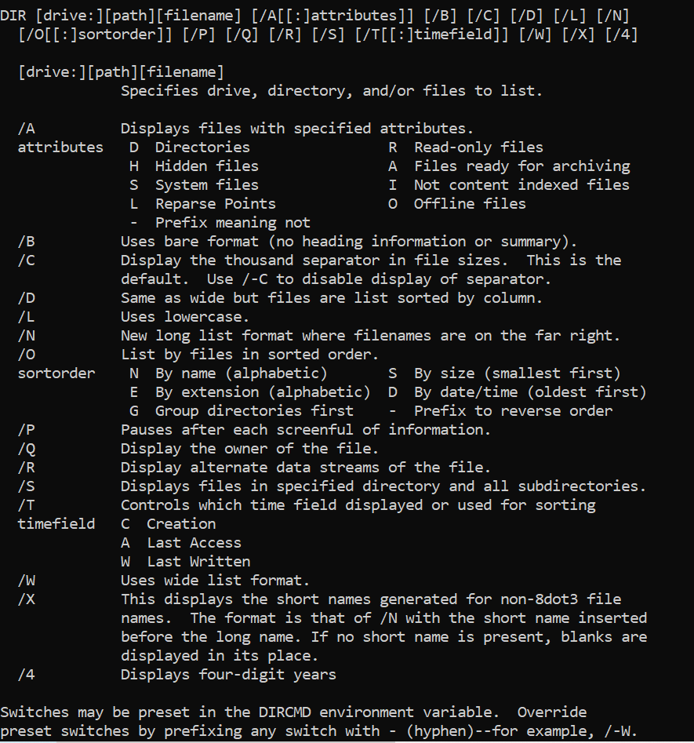

TYPE Displays the contents of a text file.

DEL Deletes one or more files.

C:\Users\KIRAN\Desktop\myGit1>git stash clear

